EIOPA Consultation paper on opinion on AI Governance and risk management : draft answer

Q1 - Do you have any comments on the context and objectives of the Opinion?
- We have some doubts about the role of EIOPA in defining common supervisory standards/interpretations on a cross-sector EU Regulation (i.e., AI Act), that locally will fall under responsibility of non-insurance regulators (e.g., ACN, not IVASS, in Italy):
  - What is the objective of this opinion?
  - Will the opinion provided by EIOPA be binding for the local regulators?

Q2 - Do you have any comments on the scope of the Opinion?
- Solvency II and other model requirements would fall under the OECD AI definition and not under the AI Act definition, we wonder how to manage this discrepancy.
- Considering the rapid advancements in AI technology since the introduction of the EU AI Act, we wonder if EIOPA should not include any perspective on AI Agents or other developments in AI.
Q3 - Do you have any comments on the risk-based approach and proportionality section? What other measures should be considered to ensure a risk-based approach and proportionality regarding the use of AI systems?
- There will likely be fewer single-use cases and more instances of autonomous systems, AI Agents, and orchestration layers. The impact on the risk assessment should be described, and guiding principles should be defined.
Q4 - Do you have any comments on the risk management system section? What other measures should be considered regarding the risk management system of AI systems?
-The IIA is promoting the 3 lines model as a key tool to strong corporate governance articulating the core components of effective governance:
- Accountability by a governing body to stakeholders for organisational oversight;
- Actions, including risk management, by management to achieve the objectives of the
organisation through risk based approach;
- Assurance, insight and advice by an independent internal audit function to provide clarity and confidence, and to promote and facilitate continuous improvement.
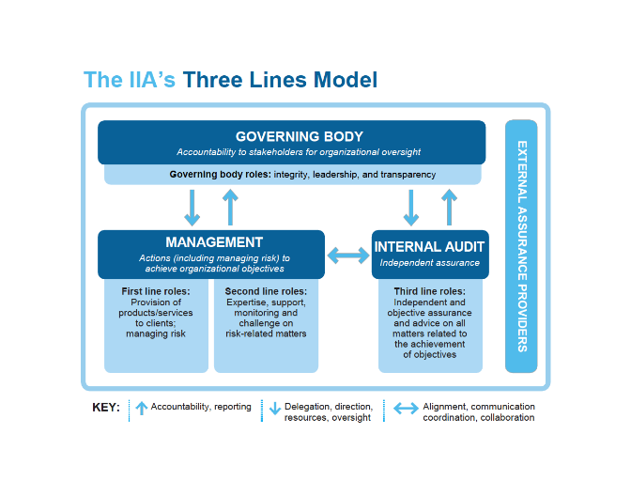
It is important to define the way to evaluate the systems and the role of the different actors to support the strategy and reduce risks.
In this context, the Internal audit department plays an important role in assisting the audit committee in this duty. As we provide independent and objective assurance and insight on the internal control systems, the governance and risk management. We also assess the other Lines and give an integrated opinion. Finally, we make recommendations, after discussion with Management, and follow up on the implementation of these actions.

-The policy document should not be limited to strategy documents. It should also describe the approach, governance, and controls for the first, second, and third lines.
Q5 - Do you have any comments on the fairness and ethics section? What other measures should be considered to ensure a fair and ethical use of AI systems?
-The guideline should describe the level of oversight be required for autonomous systems and for third-party "black box" type models, the expected controls should be defined.
-Training data should be timely to prevent model drift, and control needs to be monitored throughout the model's lifecycle.Audit should follow the proportionality principle in this context.
-The outcomes of AI systems should also be regularly monitored and audited, including with the use of fairness and non-discrimination metrics (see examples of metrics for high-risk AI systems in Annex I). To be clarified if “audited” (3.14) refers to Internal Audit activities of other audit/control activities performed by other functions. If it refers to Internal Audit, it should be clarified/introduced the risk-based approach principle, to avoid defining a pre-defined frequency for Internal Audit activities on AI.
Q6 - Do you have any comments on the data governance section? What other measures should be considered to ensure adequate data governance of AI systems?
- The data quality should not be limited to reserve and underwriting.
Q7 - Do you have any comments on the documentation and record keeping section? What other measures should be considered to ensure adequate documentation and record keeping of AI systems?
-We encourage EIOPA to make a clear distinction between internal and external audit. In the current text, EIOPA is speaking about “audit”.
-We remind that Internal Auditors follow international standards (Global Internal Audit Standards set up by IIA Global that requires internal audit functions to have a Quality Assurance and Improvement Program (QAIP) in place. The quality assurance review evaluates the efficiency and effectiveness of the internal audit function. The review must take place every 5 years, by an external provider and it is part of the monitoring of the governance process by management and the audit committee.
The internal audit function reports directly to the board, enabling it to perform its duties in an independent manner. The internal audit function plays a key role in the assessment of the product approval process. It includes the controls in place, the governance and not just the documentation.

Q8 - Do you have any comments on the transparency and explainability section? What other measures should be considered to ensure adequate transparency and explainability of AI systems?
-The requirements for explainability depend significantly on the model. Some models, like decision trees, are inherently explainable. What additional measures are needed? As mentioned in Section 3.25, there are other explainability approaches like LIME (Local Interpretable Model-agnostic Explanations) and SHAP (SHapley Additive exPlanations), as well as reperformance and post hoc explanations.

Q9 - Do you have any comments on the human oversight section? What other measures should be considered to ensure adequate human oversight of AI systems?
- There need to be specific measures to protect models from attacks based on risks.
‘”The compliance and audit functions should ensure that the use of AI systems, within the organisation is compliant with all applicable laws and regulations” (3.29). It is not the responsibility of the control functions (2d & 3rd line) to ensure compliance. It is the responsibility of the 1st line functions, otherwise, at least for internal audit, there would be a lack of independence. The proposed wording could be changed to “the compliance and internal audit functions should verify, following a risk based approach, that the internal control systems on the AI systems within the organisation, are aligned with all applicable laws and regulations”
Q10 - Do you have any comments on the accuracy, robustness and cybersecurity section? What other measures should be considered to ensure adequate accuracy, robustness and cybersecurity of AI systems?

